**Load Balancer – System Design Interview Question**

* Difficulty Level : [Easy](https://www.geeksforgeeks.org/easy/)
* Last Updated : 16 Feb, 2023

• Read

• Discuss

• Courses

• Practice

• Video

A lot of people use different web services in their day-to-day life and they get a quick response from these services as well. But, most users are unaware of the sheer scale of the process responsible for bringing content across the Internet. They are unaware of the long process that works behind the scene to scale the system. This long process involves the distribution of requests across multiple servers when thousands or millions of users make requests simultaneously on the website.

A load balancer is a critical component in system design, as it is responsible for distributing incoming requests to multiple servers to ensure that no single server becomes overwhelmed and that the overall system performance remains optimal.

In a system design interview, a candidate may be asked to design a load balancing system, or explain how they would integrate a load balancer into an existing system. When designing a load balancing system, the following key considerations should be taken into account:

1. Load balancing algorithm: The algorithm used to distribute incoming requests to the servers, such as round-robin, least connections, or IP hash.
2. Health checks: How the load balancer will determine the health of each server and ensure that only healthy servers receive incoming requests.
3. Session persistence: How the load balancer will ensure that subsequent requests from the same user are directed to the same server, to maintain session state.
4. Scalability: How the load balancing system will scale as the number of incoming requests increases, for example by adding more load balancers or using a more scalable load balancing algorithm.
5. High availability: How the load balancing system will ensure that it remains available even if one or more components fail, for example by using a redundant load balancing setup or by employing a load balancing service provided by a cloud provider.
6. Performance: How the load balancing system will impact the overall performance of the system, including the latency and throughput of incoming requests.

In summary, a load balancer is a key component in system design, as it helps to distribute incoming requests and ensure that the system remains highly available and performant. A strong understanding of load balancing is an important part of any system design interview, and is viewed as a core requirement for successful system design.

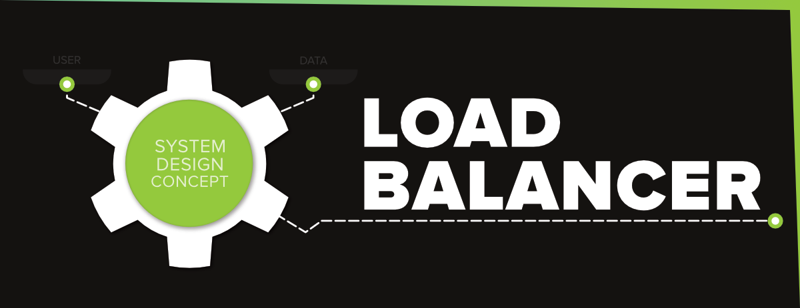

When a website becomes extremely popular, the traffic on that website increases, and the load on a single server also increases. The concurrent traffic overwhelms the single server and the website becomes slower for the users. In order to meet the request of these high volumes of data and to return the correct response in a fast and reliable manner, we need to scale the server. This can be done by adding more servers to the network and distributing all the requests across these servers.  But….***who is going to decide which request should be routed to which server…???***   
The answer is…**Load Balancer**.  Let’s understand the concept of a load balancer in detail…

**What is a Load Balancer?**

A load balancer works as a “traffic cop” sitting in front of your server and routing client requests across all servers. It simply distributes the set of requested operations (database write requests, cache queries) effectively across multiple servers and ensures that no single server bears too many requests that lead to degrading the overall performance of the application. A load balancer can be a physical device or a virtualized instance running on specialized hardware or a software process.   
Consider a scenario where an application is running on a single server and the client connects to that server directly without load balancing. It will look something like the one below…

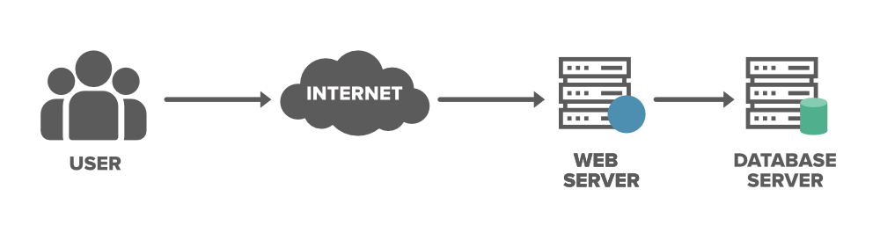

We need to discuss the two main problems with this model…

* **Single Point of Failure:**If the server goes down or something happens to the server the whole application will be interrupted and it will become unavailable for the users for a certain period. It will create a bad experience for users which is unacceptable for service providers.
* **Overloaded Servers:** There will be a limitation on the number of requests that a web server can handle. If the business grows and the number of requests increases the server will be overloaded. To solve the increasing number of requests we need to add a few more servers and we need to distribute the requests to the cluster of servers.

To solve the above issue and to distribute the number of requests we can add a load balancer in front of the web servers and allow our services to handle any number of requests by adding any number of web servers in the network. We can spread the request across multiple servers. For some reason, if one of the servers goes offline the service will be continued. Also, the latency on each request will go down because each server is not bottle-necked on RAM/Disk/CPU anymore.

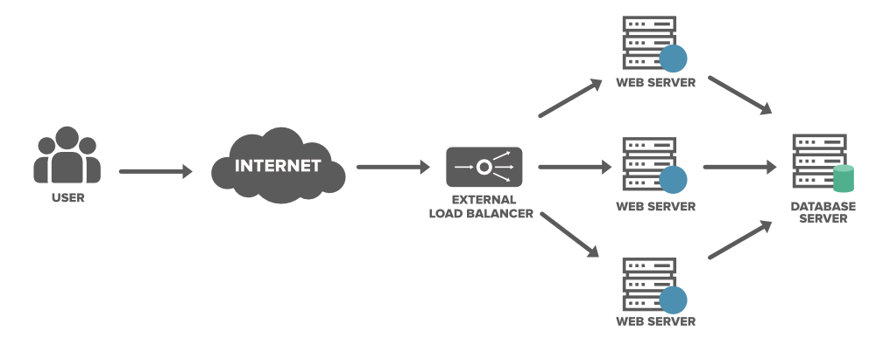

* Load balancers minimize server response time and maximize throughput.
* Load balancer ensures high availability and reliability by sending requests only to online servers
* Load balancers do continuous health checks to monitor the server’s capability of handling the request.
* Depending on the number of requests or demand load balancers add or remove the number of servers.

**Where Are Load Balancers Typically Placed?**

Below is the image where a load balancer can be placed…

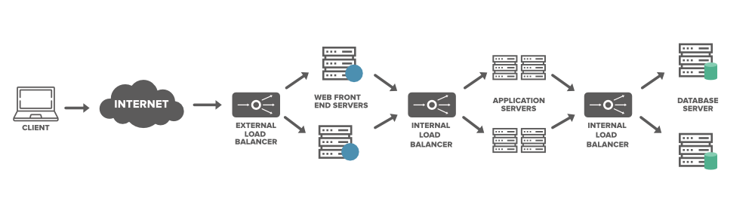

* In between the client application/user and the server
* In between the server and the application/job servers
* In between the application servers and the cache servers
* In between the cache servers the database servers

**Types of Load Balancers**

We can achieve load balancing in three ways. These are…

**1. Software Load Balancers in Clients**

As the name suggests all the logic of load balancing resides on the client application (Eg. A mobile phone app).  The client application will be provided with a list of web servers/application servers to interact with. The application chooses the first one in the list and requests data from the server. If any failure occurs persistently (after a configurable number of retries) and the server becomes unavailable, it discards that server and chooses the other one from the list to continue the process. This is one of the cheapest ways to implement load balancing.

**2. Software Load Balancers in Services**

These load balancers are the pieces of software that receive a set of requests and redirect these requests according to a set of rules. This load balancer provides much more flexibility because it can be installed on any standard device (Ex: Windows or Linux machine). It is also less expensive because there is no need to purchase or maintain the physical device, unlike hardware load balancers. You can have the option to use the off-the-shelf software load balancer or you can write your custom software (Ex: load balance Active Directory Queries of Microsoft Office365) for load balancing.

**3. Hardware Load Balancers**

As the name suggests we use a physical appliance to distribute the traffic across the cluster of network servers. These load balancers are also known as Layer 4-7 Routers and these are capable of handling all kinds of HTTP, HTTPS, TCP, and UDP traffic. HLDs provide a virtual server address to the outside world. When a request comes from a client application, it forwards the connection to the most appropriate real server doing bi-directional network address translation (NAT). HLDs can handle a large volume of traffic but it comes with a hefty price tag and it also has limited flexibility.

HLDs keep doing the health checks on each server and ensure that each server is responding properly. If any of the servers don’t produce the desired response,  it immediately stops sending the traffic to the servers. These load balancers are expensive to acquire and configure, that is the reason a lot of service providers use them only as the first entry point of user requests. Later the internal software load balancers are used to redirect the data behind the infrastructure wall.

**Different Categories of Load Balancing**

Generally, load balancers are grouped into three categories…

**1. Layer 4 (L4) Load Balancer**

In the OSI model layer 4 is the transport layer(TCP/SSL) where the routing decisions are made. Layer 4 load balancer is also referred to as**Network Load Balancing** and as the name suggests it leverages network layer information to make the routing decision for the traffic. It can control millions of requests per second and it handles all forms of TCP/UDP traffic. The decision will be based on the TCP or UDP ports that packets use along with their source and destination IP addresses. The L4 load balancer also performs Network Address Translation (NAT) on the request packet but it doesn’t inspect the actual contents of each packet. This category of load balancer maximizes the utilization and availability by distributing the traffic across IP addresses, switches, and routers.

**2. Layer 7 (L7) Load Balancer**

Layer 7 load balancer is also referred to as **Application Load Balancer** or **HTTP(S) Load Balancer**. It is one of the oldest forms of load balancing. In the OSI model, Layer 7 is the application layer (HTTP/HTTPS) where the routing decisions execute. Layer 7 adds content switching to load balancing and it uses information such as  HTTP header, cookies, uniform resource identifier, SSL session ID, and HTML form data to decide the routing request across the servers.

**3. Global Server Load Balancing (GSLB)**

Today a lot of applications are hosted in cloud data centers in multiple geographic locations. This is the reason a lot of organizations are moving to a different load balancer that can deliver applications with greater reliability and lower latency to any device or location. With the significant change in the capability of the load balancers, GSLB fulfills these expectations of IT organizations. GSLB extends the capability of L4 and L7 servers in different geographic locations and distributes a large amount of traffic across multiple data centers efficiently. It also ensures a consistent experience for end-users when they are navigating multiple applications and services in a digital workspace.

**Load Balancing Algorithms**

We need a load balancing algorithm to decide which request should be redirected to which backend server. The different system uses different ways to select the servers from the load balancer. Companies use varieties of load balancing algorithm techniques depending on the configuration. Some of the common load balancing algorithms are given below:

**1. Round Robin**

Requests are distributed across the servers in a sequential or rotational manner. For example, the first request goes to the first server, the second one goes to the second server, the third request goes to the third server and it continues further for all the requests. It is easy to implement but it doesn’t consider the load already on a server so there is a risk that one of the servers receives a lot of requests and becomes overloaded.

**2. Weighted Round Robin**

It is much similar to the round-robin technique. The only difference is, that each of the resources in a list is provided a weighted score. Depending on the weighted score the request is distributed to these servers. So in this method, some of the servers get a bigger share of the overall request.

**3. Least Connection Method**

In this method, the request will be directed to the server with the fewest number of requests or active connections. To do this load balancer needs to do some additional computing to identify the server with the least number of connections. This may be a little bit costlier compared to the round-robin method but the evaluation is based on the current load on the server. This algorithm is most useful when there is a huge number of persistent connections in the traffic unevenly distributed between the servers.

**4. Least Response Time Method**

This technique is more sophisticated than the Least connection method.  In this method, the request is forwarded to the server with the fewest active connections and the least average response time. The response time taken by the server represents the load on the server and the overall expected user experience.

**5. Source IP Hash**

In this method, the request is sent to the server based on the client’s IP address. The IP address of the client and the receiving compute instance are computed with a cryptographic algorithm.

**How to Use Load Balancing During System Design Interviews?**

In your system design interview, you’ll be asked some sort of scalability question where you’ll have to explain how load balancers help distribute the traffic and how it ensures scalability and availability of services in your application. The overall concept that you need to keep in mind from this article is…

* A load balancer enables elastic scalability which improves the performance and throughput of data. It allows you to keep many copies of data (redundancy) to ensure the availability of the system. In case a server goes down or fails you’ll have the backup to restore the services.
* Load balancers can be placed at any software layer.
* Many companies use both hardware and software to implement the load balancers, depending on the different scale points in their system.